### Auto pilot system simulator

### Project Proposal

## LOGOBA

## Supervisor

Dr. Arif Mushtaq

## Submitted by

Noman Javaid

{01-133101-039 }

Shujah Munir

{01-133101-031 }

**Department of Computer Science,**

Bahria University, Islamabad.

[15-03-2013]

# Introduction

In early days of aviation when the aircraft newly started to fly for long interval they required a lot of attention that used to cause too much fatigue. Therefore autopilot was introduced Lawrence Sperry (the son of famous inventor Elmer Sperry) demonstrated it in 1914 at an aviation safety contest held in Paris to tackle some of the responsibilities of pilot for some interval [1]. It permitted the aircraft to fly straight and level on a compass course without a pilot's attention, greatly reducing the pilot's workload. With the passage of time the airplane became the primary source of long distance traveling thus increasing the accident rate.

|  |  |
| --- | --- |
| **Odds of being on an airline flight which results in at least one fatality** | **Odds of being killed on a single airline flight** |
| 78 major world airlines 1 in 3.4 million | 78 major world airlines 1 in 4.7 million |
| Top 39 airlines with the best accident rates   1 in 10.0 million | Top 39 airlines with the best accident rates   1 in 19.8 million |
| Bottom 39 with the worst accident rates   1 in 1.5 million | Bottom 39 with the worst accident rates   1 in 2.0 million |

Odds of being involved in a fatal accident fig [1.1]

The first fatal aviation accident occurred in a Wright Model aircraft at Fort Myer, Virginia, USA, on 17 September 1908, resulting in injury to the pilot, Orville Wright and death of the passenger, Signal Corps Lieutenant Thomas Selfridge. [2]

Here are some graphs that demonstrate the accidents and fatalities ratio. 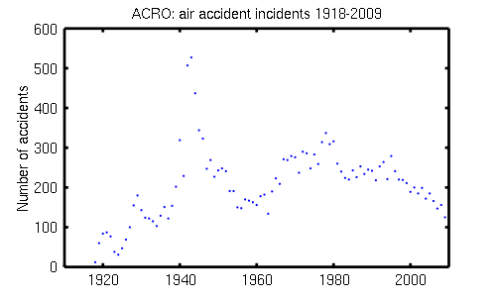

ACRO: air accident incidents 1918-2009. Fig [1.2] a

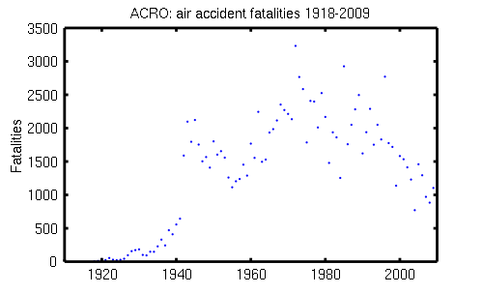

ACRO: air accident fatalities 1918-2009. Fig [1.2] b

# Objective

To design a simulated auto-pilot system to reduce air crashes.

# Problem Description

The system is intended to create a system that would avoid airplane crashes that occur due to the collision of planes with hills, mountains and ground. The reason for the creation of this system is to save lives that are on risk while travelling by air. As 47% deaths have been occurred in the plane crashes in the past century [3]. Still in the past few years more than 500 deaths occurred in Islamabad [4]. So it is felt that there is a need to upgrade the system that should help our air industry to save the people life and provide them a safe journey. The aim is to visualize the scenario and build a simulation that will show how the system should work to avoid collision with any still object.

# Methodology

In order to design an autopilot system spiral modal shall be followed. As the system might need to be integrated with the upcoming features. Programming the speed, altitude calculation in C++ and the whole system will be wrapped around in C#.

# Project Scope

The project is going to be a simple simulation that will not include all the auto-pilot functionalities. For example it will not include how the plane should maintain speed, altitude. As the real time technology is impossible to be brought at this level. The objective of this project is to develop an autopilot system that could enable the model to perform autonomous hover maneuver using only simulation and computing power.

# Feasibility Study

This project is of undergrad level and hopefully we would be able to meet our project schedule.

**Risks Involved**:

Unavailability of real time system to study. It will be a difficult job to get access to the real autopilot system.

**Resource Requirement:**

VisSim

[Adobe After Effects CS5.5](http://download.cnet.com/Adobe-After-Effects-CS5-5/3000-2186_4-10021430.html)

[Google SketchUp](http://download.cnet.com/Google-SketchUp/3000-6677_4-10257337.html)

# Solution Application Areas

The worth of project is the lives that are on stake can be saved. Our project falls directly to the airplane industry. If the project is completed as planned it would be able to save thousands of lives and billions of dollars.

# Tools/Technology

VisSim [5] – A graphical language for simulation and model-based embedded development.

Sketch up [6] – A tool used for sketching.

Adobe [7] – A tool that delivers cinematic visual effects and motion graphics.

# Expertise of the Team Members

This project is of equal interest to both of the members. Some relevant courses about Computer Graphics have been studied that will help greatly in the project.

# 10. Milestones

The main goal is to design a simulation of an airplane to reduce crashes with mountains and ground or any other still object in the path. The project shall be finished before the proposed deadline.

# References

[1] ["Now - The Automatic Pilot"](http://books.google.com/books?id=4ykDAAAAMBAJ&pg=PA22) Popular Science Monthly, February 1930, p. 22.

[1.1] Kebabjian, Richard. accident database Odds of being involved in a fatal accident ,OAG Aviation & PlaneCrashInfo.com accident database, 20 years of data (1993 - 2012) http://planecrashinfo.com/cause.htm

[1.2 a][1.2b]This is a graph showing statistics of air accident incidents 1918-2009, from ACRO records.

Author: SSR.

[2] "Wright Brothers – First Fatal Airplane Crash in 1908". About.com Inventors. Retrieved 22 July 2012.

[3] Kebabjian, Richard. “Accident Database.” “PlaneCrashInfo.com”

[4] Zaheer, Sidra. “List of Airline Crash Incidents Involving Pakistan”. Pakistan Insider. (April 22, 2012). “http://insider.pk/travel/list-of-airline-crash-incidents-involving-pakistan-with-photos-and-summaries/”

[5] Visual Solutions Incorporated. “VisSim.” (2013). “<http://www.vissim.com/>”

[6] Google. “Sketch up.” (2013). “[http://www.sketchup.com/](http://www.sketchup.com/product/newin7.html) ”

[7] Adobe. “After Effects” (2013).“http://www.adobe.com/products/aftereffects.html”